Assignment - 1 Introduction to ASP.NET Controls & State Management

Module - 1
- A basic contact form where the user enters their name, and on button click, the name is displayed in a label.
  - Aim :
  - Objective :
  - Theory :
  - Code :
<%@ Page Language="C#" AutoEventWireup="true" CodeBehind="WebForm1.aspx.cs" Inherits="hw.WebForm1" %>

<!DOCTYPE html>

<html xmlns="http://www.w3.org/1999/xhtml">
<head runat="server">
<title></title>
</head>
<body>
<form id="form1" runat="server">
<div>
<asp:Button ID="Button1" runat="server" BackColor="#9966FF" BorderColor="#FF6600" Height="23px" OnClick="Button1_Click" Text="submit" Width="88px" />
</div>
</form>
</body>
</html>

using System;
using System.Collections.Generic; using System.Linq;
using System.Web; using System.Web.UI;
using System.Web.UI.WebControls;

namespace hw
{
public partial class WebForm1 : System.Web.UI.Page
{
protected void Page_Load(object sender, EventArgs e)
{

}
protected void Button1_Click(object sender, EventArgs e)
{
Response.Write("welcome in timscdr");
}
}
}
  - Output :
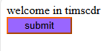
- Take three Button controls, Red, Green, and Blue, and one Label control. Using CSS class, when a user presses any of the three buttons, the appearance of the label will change accordingly.
  - Aim:
  - Objective
  - Theory :
  - Code :
<%@ Page Language="C#" AutoEventWireup="true" CodeBehind="WebForm2.aspx.cs" Inherits="WebApplication3.WebForm2" %>

<!DOCTYPE html>

<html xmlns="http://www.w3.org/1999/xhtml">
<head runat="server">
<title></title>
<style type="text/css">
.red{
background-color:red; color:white;
}
.green{
background-color:green; color:white;
}
.blue{
background-color:blue; color:white;
}
</style>

</head>
<body>
<form id="form1" runat="server">
<div>
<asp:Button ID="Button1" runat="server" BackColor="Red" ForeColor="White" OnClick="Button1_Click" Text="Red" Width="71px" /> &nbsp;&nbsp;&nbsp;&nbsp;&nbsp;&nbsp;&nbsp;&nbsp;&nbsp;&nbsp;&nbsp;&nb sp;&nbsp;&nbsp;
<asp:Button ID="Button2" runat="server" BackColor="#009900" ForeColor="White" OnClick="Button2_Click" Text="Green" Width="73px" /> &nbsp;&nbsp;&nbsp;&nbsp;&nbsp;&nbsp;&nbsp;&nbsp;&nbsp;&nbsp;&nbsp;&nb sp;&nbsp;
<asp:Button ID="Button3" runat="server" BackColor="#0033CC" ForeColor="White" OnClick="Button3_Click" Text="Blue" Width="65px" />
<br />
<br />
<asp:Label ID="Label1" runat="server"></asp:Label>
<br />
</div>
</form>
</body>
</html>

aspx.cs
using System;
using System.Collections.Generic; using System.Linq;
using System.Web; using System.Web.UI;
using System.Web.UI.WebControls;

namespace WebApplication3
{
public partial class WebForm2 : System.Web.UI.Page
{
protected void Page_Load(object sender, EventArgs e)
{

}

protected void Button3_Click(object sender, EventArgs e)
{
Label1.Text = "This is blue color"; Label1.Visible = true;

Label1.CssClass = "blue";
}

protected void Button1_Click(object sender, EventArgs e)
{
Label1.Text = "This is red color"; Label1.Visible = true; Label1.CssClass = "red";
}

protected void Button2_Click(object sender, EventArgs e)
{
Label1.Text = "This is red color"; Label1.Visible = true; Label1.CssClass = "green";
}
}
}

  - Output :
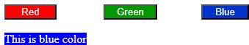

- Write a program to give font effects (name, size, effect) to the text (without using Button control).

  - Aim:
  - Objective:
  - Theory :
  - Code :
using System;
using System.Collections.Generic; using System.Linq;
using System.Web; using System.Web.UI;
using System.Web.UI.WebControls;

namespace WebApplication3
{
public partial class WebForm2 : System.Web.UI.Page

{
protected void Page_Load(object sender, EventArgs e)
{

}
)
protected void Button3_Click(object sender, EventArgs e)
{
Label1.Text = "This is blue color"; Label1.Visible = true; Label1.CssClass = "blue";
}

protected void Button1_Click(object sender, EventArgs e)
{
Label1.Text = "This is red color"; Label1.Visible = true; Label1.CssClass = "red";
}

protected void Button2_Click(object sender, EventArgs e)
{
Label1.Text = "This is red color"; Label1.Visible = true; Label1.CssClass = "green";
}
}
}
aspx.cs
using System;
using System.Collections.Generic; using System.Linq;
using System.Web; using System.Web.UI;
using System.Web.UI.WebControls;

namespace WebApplication3
{
public partial class WebForm3 : System.Web.UI.Page
{
protected void Page_Load(object sender, EventArgs e)
{

}

protected void DropDownList1_SelectedIndexChanged(object sender, EventArgs e)
{
Label1.Font.Name = DropDownList1.SelectedItem.Text.ToString();
}
protected void DropDownList2_SelectedIndexChanged(object sender, EventArgs e)
{
Label1.Font.Size = Convert.ToInt32(DropDownList1.SelectedItem.Text.ToString());
}

protected void CheckBox1_CheckedChanged(object sender, EventArgs e)
{
if (CheckBox1.Checked)
{
Label1.Font.Bold = true;

}
else
{
Label1.Font.Bold = false;
}
}

protected void CheckBox2_CheckedChanged(object sender, EventArgs e)
{
if (CheckBox1.Checked)
{
Label1.Font.Italic = true;

}
else
{
Label1.Font.Italic = false;
}
}

protected void CheckBox3_CheckedChanged(object sender, EventArgs e)
{
if (CheckBox1.Checked)
{
Label1.Font.Underline = true;

}
else
{
Label1.Font.Underline = false;
}
}
}
}

- Output :
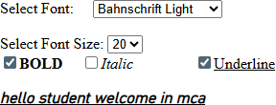

- Design a web application as follows. On submitting the form data confirm the selection made in the following format on one LABEL Control.

Thank you very much .
You have chosen for breakfast. I will prepare it for you .
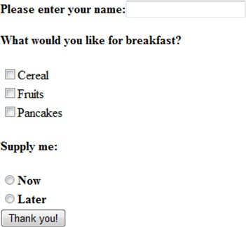

  - Code :Webform.aspx

<%@ Page Language="C#" AutoEventWireup="true" CodeBehind="WebForm1.aspx.cs" Inherits="WebApplication1.WebForm1"
%>

<!DOCTYPE html>

<html xmlns="http://www.w3.org/1999/xhtml">
<head runat="server">
<title></title>
</head>
<body>
<form id="form1" runat="server">
<asp:Label ID="Label1" runat="server" Text="Please enter your name:"></asp:Label>
<asp:TextBox ID="TextBox1" runat="server" Height="18px" style="margin-left: 13px"></asp:TextBox>
<div>
<br />
<asp:Label ID="Label2" runat="server" Text="what you like for breakfast ?"></asp:Label>
<br />
<asp:CheckBox ID="CheckBox1" runat="server" Text="Cereal" />
<br />
<asp:CheckBox ID="CheckBox2" runat="server" Text="Fruits" />
<br />
<asp:CheckBox ID="CheckBox3" runat="server" Text="Pancakes"
/>
<br />
<br />
Supply are:<br />
<asp:RadioButton ID="RadioButton1" runat="server"
GroupName="Time" Text="Now" />
<br />

Text="Later" />
<br />
<br />
<asp:RadioButton ID="RadioButton2" runat="server"

<asp:Button ID="Button1" runat="server"

OnClick="Button1_Click" style="margin-bottom: 0px" Text="Thank you"
/>

&nbsp;&nbsp;&nbsp;&nbsp;&nbsp;&nbsp;&nbsp;&nbsp;&nbsp;
<br />
<br />
<br />
<asp:Label ID="Label3" runat="server"></asp:Label>
<br />
<br />
</div>
</form>
</body>
</html> webform1.aspx.cs using System;
using System.Collections.Generic; using System.Linq;
using System.Web; using System.Web.UI;
using System.Web.UI.WebControls;

namespace WebApplication1
{
public partial class WebForm1 : System.Web.UI.Page
{
protected void Page_Load(object sender, EventArgs e)
{

}
protected void Button1_Click(object sender, EventArgs e)
{
string name = TextBox1.Text; string breakfast = null; string time = null;
if (CheckBox1.Checked)
{
breakfast += CheckBox1.Text;
}
if (CheckBox2.Checked)
{
breakfast += CheckBox2.Text;
}

if (CheckBox3.Checked)
{
breakfast += CheckBox3.Text;
}
if (RadioButton1.Checked)
{
time += RadioButton1.Text;
}
if (RadioButton2.Checked)
{
time += RadioButton2.Text;
}
Label3.Text = "Thank you " + name + " you have choosen " +
breakfast + " Supply are " + time;
}
}
}

- Output :
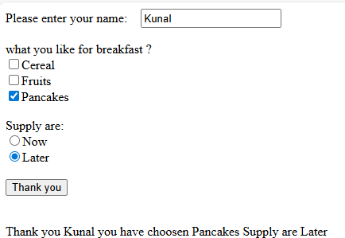

- Write a program to demonstrate Postback
  - Aim:
  - Objective:
  - Theory :
  - Code :

Webform1.aspx
<%@ Page Language="C#" AutoEventWireup="true" CodeBehind="WebForm2.aspx.cs" Inherits="WebApplication1.WebForm2"
%>

<!DOCTYPE html>

<html xmlns="http://www.w3.org/1999/xhtml">
<head runat="server">
<title></title>
</head>
<body>
<form id="form1" runat="server">
<div>
Select State:<asp:DropDownList ID="DropDownList1"
runat="server" AutoPostBack="True" OnSelectedIndexChanged="DropDownList1_SelectedIndexChanged">
</asp:DropDownList>
<br />
Selcet City:<asp:DropDownList ID="DropDownList2"
runat="server">
</asp:DropDownList>
</div>
</form>
</body>
</html>

Webform1.aspx.cs using System;
using System.Collections.Generic; using System.Linq;
using System.Web; using System.Web.UI;
using System.Web.UI.WebControls;

namespace WebApplication1
{
public partial class WebForm2 : System.Web.UI.Page
{
protected void Page_Load(object sender, EventArgs e)

{
if (!Page.IsPostBack)
{
DropDownList1.Items.Add("Maharashtra"); DropDownList1.Items.Add("Gujrat"); DropDownList1.Items.Add("Goa");

}
}

protected void DropDownList1_SelectedIndexChanged(object sender, EventArgs e)
{
DropDownList2.Items.Clear(); if(DropDownList1.SelectedItem.Text == "Maharashtra")
{
DropDownList2.Items.Add("Mumbai"); DropDownList2.Items.Add("pune"); DropDownList2.Items.Add("kokan");

}
else if (DropDownList1.SelectedItem.Text == "Gujrat")
{
DropDownList2.Items.Add("Surat"); DropDownList2.Items.Add("Ahemdabad"); DropDownList2.Items.Add("Rajkot");
}
else if (DropDownList1.SelectedItem.Text == "Goa")
{
DropDownList2.Items.Add("MAdgaon"); DropDownList2.Items.Add("Thiviam"); DropDownList2.Items.Add("Panji");
}

}
}
}

  - Output :

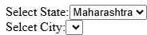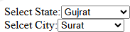
- Write a program to upload your profile picture and display it in image control (file format should be .jpg, .jpeg or .png format)

  - Aim :
  - Objective :
  - Theory :
  - Code : Webform1.aspx
<%@ Page Language="C#" AutoEventWireup="true" CodeBehind="WebForm3.aspx.cs" Inherits="WebApplication1.WebForm3"
%>

<!DOCTYPE html>

<html xmlns="http://www.w3.org/1999/xhtml">
<head runat="server">
<title></title>
</head>
<body>
<form id="form1" runat="server">
<div>
<asp:FileUpload ID="FileUpload1" runat="server" />
<br />
<br />
<asp:Image ID="Image1" runat="server" Height="175px" Visible="False" Width="250px" />
<br />
<br />
<asp:Button ID="Button1" runat="server" OnClick="Button1_Click" Text="Upload file" />
<br />
<br />
<br />
<asp:Label ID="Label1" runat="server"></asp:Label>
</div>
</form>
</body>

</html>

webform1.aspx.cs using System;
using System.Collections.Generic; using System.IO;
using System.Linq; using System.Web; using System.Web.UI;
using System.Web.UI.WebControls;

namespace WebApplication1
{
public partial class WebForm3 : System.Web.UI.Page
{
protected void Page_Load(object sender, EventArgs e)
{

}

protected void Button1_Click(object sender, EventArgs e)
{
try
{
string filename = Path.GetFileName(FileUpload1.FileName); string ext = Path.GetExtension(filename);
if (ext.ToLower() == ".jpg")
{
FileUpload1.SaveAs(Server.MapPath("~/images/") + filename); Label1.Text = "File uploaded successfully";
Image1.Visible = true;
Image1.ImageUrl = "~/images/" + filename;

}
if (ext.ToLower() == ".png")
{
FileUpload1.SaveAs(Server.MapPath("~/images/") + filename); Label1.Text = "File uploaded successfully";
Image1.Visible = true;
Image1.ImageUrl = "~/images/" + filename;

}
if (ext.ToLower() == ".jpeg")
{
FileUpload1.SaveAs(Server.MapPath("~/images/") + filename); Label1.Text = "File uploaded successfully";
Image1.Visible = true;
Image1.ImageUrl = "~/images/" + filename;

}

}
catch
{

}
}
}
}
  - Output :
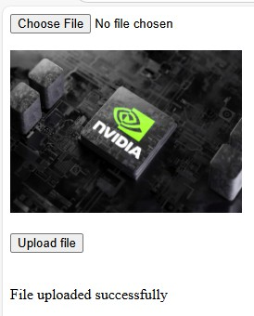

- Write a program to demonstrate Ad Rotator Control.

  - Aim:
  - Objective:
  - Theory :
  - Code : Webform.apsx
<%@ Page Language="C#" AutoEventWireup="true" CodeBehind="WebForm1.aspx.cs" Inherits="WebApplication2.WebForm1"
%>

<!DOCTYPE html>

<html xmlns="http://www.w3.org/1999/xhtml">
<head runat="server">
<title></title>
</head>
<body>
<form id="form1" runat="server">
<div>
IT Company<br />
<br />
<asp:AdRotator ID="AdRotator1" runat="server" DataSourceID="XmlDataSource1" KeywordFilter="IT Company" />
<asp:XmlDataSource ID="XmlDataSource1" runat="server" DataFile="~/XMLFile1.xml"></asp:XmlDataSource>
<br />
<br />
<br /> CAr<br />
<asp:AdRotator ID="AdRotator2" runat="server" DataSourceID="XmlDataSource2" KeywordFilter="CAr" />
<asp:XmlDataSource ID="XmlDataSource2" runat="server" DataFile="~/XMLFile1.xml"></asp:XmlDataSource>
</div>
</form>
</body>
</html>

Xml.file1
<?xml version="1.0" encoding="utf-8" ?>
<Advertisements>

<Ad>
<ImageUrl>~/image/meta.pnj</ImageUrl>
<Width>250</Width>
<Height>200</Height>
<NavigateUrl>https://www.meta.ai/</NavigateUrl>
<AlternateText>Meta</AlternateText>
<Impression>100</Impression>
<Keyword>IT Company</Keyword>
</Ad>
<Ad>

</Ad>
<Ad>
<ImageUrl>~/image/Nvidia.jpg</ImageUrl>
<Width>250</Width>
<Height>200</Height>
<NavigateUrl>https://www.nvidia.com/en-in/</NavigateUrl>
<AlternateText>Nvidia</AlternateText>
<Impression>130</Impression>
<Keyword>IT Company</Keyword>

<ImageUrl>~/image/mic.jpg</ImageUrl>
<Width>250</Width>
<Height>200</Height>

<NavigateUrl>https://www.microsoft.com/en-in/</NavigateUrl>
<AlternateText>microsoft</AlternateText>
<Impression>108</Impression>
<Keyword>IT Company</Keyword>
</Ad>
<Ad>
<ImageUrl>~/image/lam.jpg</ImageUrl>
<Width>250</Width>
<Height>200</Height>

<NavigateUrl>https://www.bmw.in/en/index.html</NavigateUrl>
<AlternateText>lam</AlternateText>
<Impression>200</Impression>
<Keyword>CAr</Keyword>
</Ad>
<Ad>
<ImageUrl>~/image/p.jpg</ImageUrl>

<Width>250</Width>
<Height>200</Height>

<NavigateUrl>https://www.bmw.in/en/index.html</NavigateUrl>
<AlternateText>p</AlternateText>
<Impression>300</Impression>
<Keyword>CAr</Keyword>
</Ad>
<Ad>
<ImageUrl>~/image/v.jpg</ImageUrl>
<Width>250</Width>
<Height>200</Height>

<NavigateUrl>https://www.bmw.in/en/index.html</NavigateUrl>
<AlternateText>v</AlternateText>
<Impression>100</Impression>
<Keyword>CAr</Keyword>
</Ad>

</Advertisements>
  - Output :
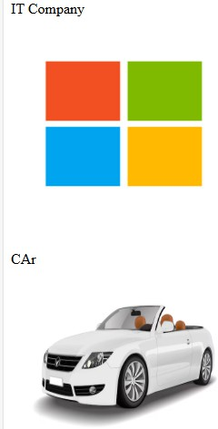
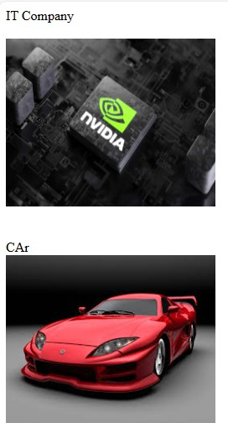

- Write a program to demonstrate Navigation Controls.
  - Aim:
  - Objective:
  - Theory :

  - Code : Home.aspx
<%@ Page Language="C#" AutoEventWireup="true" CodeBehind="Home.aspx.cs" Inherits="naviagtion.WebForm1" %>

<!DOCTYPE html>

<html xmlns="http://www.w3.org/1999/xhtml">
<head runat="server">
<title></title>
</head>
<body>
<form id="form1" runat="server">
<div>
<asp:Menu ID="Menu1" runat="server" DataSourceID="SiteMapDataSource1">
</asp:Menu>

runat="server" />
<br />
<br />
<br />
<asp:SiteMapDataSource ID="SiteMapDataSource1"

<asp:TreeView ID="TreeView1" runat="server"

DataSourceID="SiteMapDataSource1" LineImagesFolder="~/TreeLineImages" ShowLines="True">
</asp:TreeView>
<br />
<br />
<br />
</div>
</form>
</body>
</html>

Web.Sitemap
<?xml version="1.0" encoding="utf-8" ?>
<siteMap xmlns="http://schemas.microsoft.com/AspNet/SiteMap-File-1.0" >
<siteMapNode url="Home.aspx" title="Home" description="Home page">

<siteMapNode url="Aboutus.aspx" title="about" description="Aboutus" ></siteMapNode>
<siteMapNode url="ContactUs.aspx" title="contact" description="Contactus if any problem arises" ></siteMapNode>
<siteMapNode url="Service.aspx" title="sevice" description="srvices">

<siteMapNode url="Service1.aspx" title="sevice" description="sevices"> </siteMapNode>
</siteMapNode>
</siteMapNode>
</siteMap>

  - Output :
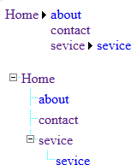

- Write a program to demonstrate Calendar control and highlight all holidays of October 2025.
  - Aim:
  - Objective
  - Theory :
  - Code : webform.aspx
<%@ Page Language="C#" AutoEventWireup="true" CodeBehind="WebForm1.aspx.cs" Inherits="WebApplication3.WebForm1" %>

<!DOCTYPE html>

<html xmlns="http://www.w3.org/1999/xhtml">
<head runat="server">
<title></title>

</head>
<body>
<form id="form1" runat="server">
<div>
<asp:Calendar ID="Calendar1" runat="server" BackColor="#FFFFCC" BorderColor="#FFCC66" BorderWidth="1px" DayNameFormat="Full" Font-Names="Verdana" Font-Size="8pt" ForeColor="#663399" Height="200px" OnDayRender="Calendar1_DayRender" OnSelectionChanged="Calendar1_SelectionChanged" ShowGridLines="True" VisibleDate="2025-10-06" Width="220px">
<DayHeaderStyle BackColor="#FFCC66" Font-Bold="True"
Height="1px" />
<NextPrevStyle Font-Size="9pt" ForeColor="#FFFFCC" />
<OtherMonthDayStyle ForeColor="#CC9966" />
<SelectedDayStyle BackColor="#CCCCFF" Font-Bold="True" />
<SelectorStyle BackColor="#FFCC66" />
<TitleStyle BackColor="#990000" Font-Bold="True" Font-Size="9pt" ForeColor="#FFFFCC" />
<TodayDayStyle BackColor="#FFCC66" ForeColor="White" />
</asp:Calendar>
</div>
</form>
</body>
</html>

Webform.aspx.cs using System;
using System.Collections.Generic; using System.Linq;
using System.Web; using System.Web.UI;
using System.Web.UI.WebControls;

namespace WebApplication3
{
public partial class WebForm1 : System.Web.UI.Page
{
protected void Page_Load(object sender, EventArgs e)
{

}
protected void Calendar1_DayRender(object sender, DayRenderEventArgs
e)
{
DateTime d1 = new DateTime(2025, 10, 2); if (e.Day.Date.ToString() == d1.ToString())
{
e.Cell.Controls.Add(new LiteralControl("\n Gandhi Jayanti")); e.Cell.BackColor = System.Drawing.Color.Aqua; e.Cell.Font.Bold= true;
e.Cell.ForeColor = System.Drawing.Color.Black;

}
DateTime d2 = new DateTime(2025, 10, 20); if (e.Day.Date.ToString() == d2.ToString())
{
e.Cell.Controls.Add(new LiteralControl("\n Laxmi puja ")); e.Cell.BackColor = System.Drawing.Color.Aqua; e.Cell.Font.Bold = true;
e.Cell.ForeColor = System.Drawing.Color.Black;

}
DateTime d3 = new DateTime(2025, 10, 25); if (e.Day.Date.ToString() == d3.ToString())
{
e.Cell.Controls.Add(new LiteralControl("\n Chhath Puja ")); e.Cell.BackColor = System.Drawing.Color.Aqua; e.Cell.Font.Bold = true;
e.Cell.ForeColor = System.Drawing.Color.Black;

}

}
}
}
  - Output :

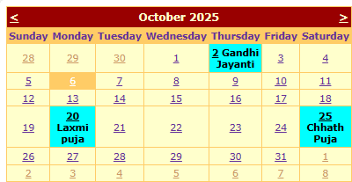

- Create a registration form having the following UI.
  - Aim :
  - Objective :
  - Theory :
  - Code : webform.aspx
<%@ Page Language="C#" AutoEventWireup="true" CodeBehind="WebForm2.aspx.cs" Inherits="WebApplication3.WebForm2" %>

<!DOCTYPE html>

<html xmlns="http://www.w3.org/1999/xhtml">
<head runat="server">
<title></title>
<style type="text/css">
.auto-style1 { width: 100%;
}
.auto-style2 { width: 299px;
}
.auto-style3 { width: 263px;
}
.auto-style4 { width: 299px; height: 26px;
}
.auto-style5 {

width: 263px; height: 26px;
}
.auto-style6 { height: 26px;
}
.auto-style7 { width: 299px; height: 40px;
}
.auto-style8 { width: 263px; height: 40px;
}
.auto-style9 { height: 40px;
}
.auto-style10 { width: 299px; height: 42px;
}
.auto-style11 { width: 263px; height: 42px;
}
.auto-style12 { height: 42px;
}
</style>
<script type="text/javascript"> function My(src, args) {
var input = document.getElementById('<%= TextBox6.ClientID
%>').value;
args.Isvalid = input.length > 8;
}
</script>
</head>
<body style="height: 557px">
<form id="form1" runat="server">
<div style="height: 564px; width: 1188px">

<table class="auto-style1">
<tr>
<td class="auto-style2">Full Name:</td>
<td class="auto-style3">
<asp:TextBox ID="TextBox1" runat="server" CausesValidation="True" ValidationGroup="s"></asp:TextBox>
</td>
<td>
<asp:RequiredFieldValidator ID="RequiredFieldValidator1" runat="server" ControlToValidate="TextBox1" Display="Dynamic" ErrorMessage="Enter a full name is mandatory">full name is manadatory</asp:RequiredFieldValidator>
</td>
</tr>
<tr>
<td class="auto-style7">Address:</td>
<td class="auto-style8">
<asp:TextBox ID="TextBox2" runat="server" CausesValidation="True" TextMode="MultiLine"></asp:TextBox>
</td>
<td class="auto-style9">
<asp:RequiredFieldValidator ID="RequiredFieldValidator2" runat="server" ControlToValidate="TextBox2" Display="Dynamic" ErrorMessage="Address field cannot be empty"></asp:RequiredFieldValidator>
</td>
</tr>
<tr>
<td class="auto-style2">State:</td>
<td class="auto-style3">
<asp:DropDownList ID="DropDownList1" runat="server" CausesValidation="True" ValidationGroup="s">
<asp:ListItem>Select State</asp:ListItem>
<asp:ListItem>Maharashtar</asp:ListItem>
<asp:ListItem>HAriyana</asp:ListItem>
<asp:ListItem></asp:ListItem>
</asp:DropDownList>
</td>
<td>
<asp:RequiredFieldValidator ID="RequiredFieldValidator3" runat="server" ControlToValidate="DropDownList1" Display="Dynamic"

ErrorMessage="Select state" InitialValue="Select State" ValidationGroup="s"></asp:RequiredFieldValidator>
</td>
</tr>
<tr>
<td class="auto-style4">Mobile No:</td>
<td class="auto-style5">
<asp:TextBox ID="TextBox4" runat="server" TextMode="Number"></asp:TextBox>
</td>
<td class="auto-style6">
<asp:RequiredFieldValidator ID="RequiredFieldValidator4" runat="server" ControlToValidate="TextBox4" ErrorMessage="Enter a mobile number" ValidationGroup="s"></asp:RequiredFieldValidator>
<br />
<asp:RegularExpressionValidator ID="RegularExpressionValidator2" runat="server" ErrorMessage="Invalid mobile number" ValidationExpression="\d{10}" ControlToValidate="TextBox4"></asp:RegularExpressionValidator>
<br />
</td>
</tr>
<tr>
<td class="auto-style2">Email:</td>
<td class="auto-style3">
<asp:TextBox ID="TextBox5" runat="server"
CausesValidation="True" TextMode="Email" ValidationGroup="s"></asp:TextBox>
</td>
<td>
<asp:RequiredFieldValidator ID="RequiredFieldValidator5" runat="server" ControlToValidate="TextBox5" Display="Dynamic" ErrorMessage="Enter a email" ValidationGroup="s"></asp:RequiredFieldValidator>
<br />
<asp:RegularExpressionValidator ID="RegularExpressionValidator1" runat="server" ErrorMessage="invalid email id" ValidationExpression="\w+([-+.']\w+)*@\w+([-.]\w+)*\.\w+([-.]\w+)*" ControlToValidate="TextBox5"></asp:RegularExpressionValidator>
<br />

</td>
</tr>
<tr>
<td class="auto-style10">Password:</td>
<td class="auto-style11">
<asp:TextBox ID="TextBox6" runat="server"
CausesValidation="True" TextMode="Password" ValidationGroup="s"></asp:TextBox>
</td>
<td class="auto-style12">
<asp:RequiredFieldValidator ID="RequiredFieldValidator6" runat="server" ControlToValidate="TextBox6" Display="Dynamic" ErrorMessage="Enter password"
ValidationGroup="s"></asp:RequiredFieldValidator>
<br />
<asp:CustomValidator ID="CustomValidator1" runat="server" ClientValidationFunction="My" ControlToValidate="TextBox6" ErrorMessage="enter more than 8 character" ValidationGroup="s" Display="Dynamic">enter more than 8 character</asp:CustomValidator>
<br />
</td>
</tr>
<tr>
<td class="auto-style4">Confirm Password:</td>
<td class="auto-style5">
<asp:TextBox ID="TextBox7" runat="server"
CausesValidation="True" TextMode="Password" ValidationGroup="s"></asp:TextBox>
</td>
<td class="auto-style6">
<asp:RequiredFieldValidator ID="RequiredFieldValidator7" runat="server" ControlToValidate="TextBox7" ErrorMessage="password does not match"></asp:RequiredFieldValidator>
<asp:CompareValidator ID="CompareValidator1" runat="server" ControlToCompare="TextBox6" ControlToValidate="TextBox7" ErrorMessage="CompareValidator"></asp:CompareValidator>
</td>
</tr>
<tr>
<td class="auto-style2">Enter Class(6-12)</td>

<td class="auto-style3">
<asp:TextBox ID="TextBox8" runat="server" CausesValidation="True" ValidationGroup="s"></asp:TextBox>
</td>
<td>
<asp:RequiredFieldValidator ID="RequiredFieldValidator8" runat="server" ControlToValidate="TextBox8" ErrorMessage="Enter a range between(6-12)"></asp:RequiredFieldValidator>
<asp:RangeValidator ID="RangeValidator1" runat="server" ControlToValidate="TextBox8" ErrorMessage="RangeValidator" MaximumValue="12" MinimumValue="6" Type="Integer" ValidationGroup="s"></asp:RangeValidator>
</td>
</tr>
</table>
<asp:ValidationSummary ID="ValidationSummary1" runat="server" />
<asp:Label ID="Label1" runat="server"></asp:Label>
<br />
<br />
<asp:Button ID="Button1" runat="server" Text="Submit" ValidationGroup="s" OnClick="Button1_Click" /> &nbsp;&nbsp;&nbsp;&nbsp;&nbsp;&nbsp;&nbsp;&nbsp;&nbsp;&nbsp;&nbsp; &nbsp;&nbsp;&nbsp;&nbsp;&nbsp;&nbsp;
<asp:Button ID="Button2" runat="server" Text="Cancel" OnClick="Button2_Click" />
<br /> &nbsp;&nbsp;&nbsp;&nbsp;&nbsp;&nbsp;&nbsp;&nbsp;&nbsp;&nbsp;&nbsp; &nbsp;&nbsp;&nbsp;&nbsp;&nbsp;&nbsp;&nbsp;&nbsp;&nbsp;&nbsp;
</div>
</form>
</body>
</html>

webform1.aspx.cs using System;
using System.Collections.Generic; using System.Linq;
using System.Web; using System.Web.UI;
using System.Web.UI.WebControls;

namespace WebApplication3
{
public partial class WebForm2 : System.Web.UI.Page
{
protected void Page_Load(object sender, EventArgs e)
{

}

protected void Button1_Click(object sender, EventArgs e)
{
Label1.Text = "Data entered successfully";
}

protected void Button2_Click(object sender, EventArgs e)
{
TextBox1.Text = string.Empty; TextBox2.Text = string.Empty; TextBox4.Text = string.Empty; TextBox5.Text = string.Empty; TextBox6.Text = string.Empty; TextBox7.Text = string.Empty; TextBox8.Text = string.Empty; Label1.Visible = false;
}
}
}

<!--
Web.config
<?xml version="1.0" encoding="utf-8"?>

For more information on how to configure your ASP.NET application, please visit https://go.microsoft.com/fwlink/?LinkId=169433
-->
<configuration>
<system.web>
<compilation debug="true" targetFramework="4.7.2" />
<httpRuntime targetFramework="4.7.2" />
</system.web>
<system.codedom>

<compilers>
<compiler language="c#;cs;csharp" extension=".cs"
type="Microsoft.CodeDom.Providers.DotNetCompilerPlatform.CSharpCodeProvider, Microsoft.CodeDom.Providers.DotNetCompilerPlatform, Version=2.0.1.0, Culture=neutral, PublicKeyToken=31bf3856ad364e35" warningLevel="4" compilerOptions="/langversion:default /nowarn:1659;1699;1701" />
<compiler language="vb;vbs;visualbasic;vbscript" extension=".vb" type="Microsoft.CodeDom.Providers.DotNetCompilerPlatform.VBCodeProvider, Microsoft.CodeDom.Providers.DotNetCompilerPlatform, Version=2.0.1.0, Culture=neutral, PublicKeyToken=31bf3856ad364e35" warningLevel="4" compilerOptions="/langversion:default /nowarn:41008 /define:_MYTYPE=\&quot;Web\&quot;
/optionInfer+" />
</compilers>
</system.codedom>
<appSettings>
<add key="ValidationSettings:UnobtrusiveValidationMode" value="None" />
</appSettings>
</configuration>

- Output :
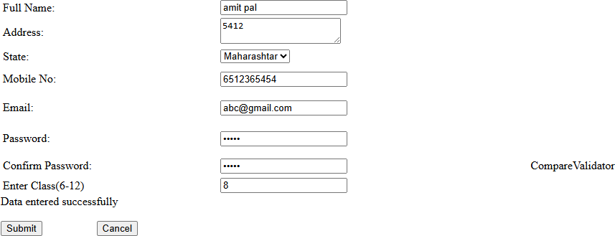

- Write a program to demonstrate Master Page.
  - Aim:
  - Objective:
  - Theory :
  - Code : Site1.master:

<%@ Master Language="C#" AutoEventWireup="true" CodeBehind="Site1.master.cs" Inherits="WebApplication4.Site1" %>

<!DOCTYPE html>

<html>
<head runat="server">
<title></title>
<asp:ContentPlaceHolder ID="head" runat="server">
</asp:ContentPlaceHolder>
</head>
<body>
<form id="form1" runat="server">
<div>
<div
style="background-color:palevioletred;color:black;padding:20px;margin-right:10 px;">
<div><img src="https://img.freepik.com/free-vector/bird-colorful-gradient-design-vector_343 694-2506.jpg?semt=ais_hybrid&w=740&q=80"; style=" height:100px;width:100px; align-self:self-end;"/></div>
<h1>Amazon.in</h1>
<a href="home.aspx" style="color:antiquewhite; margin-right:10px;">Home</a>
<a href="about.aspx" style="color:antiquewhite; margin-right:10px;">about</a>
<a href="Service.aspx" style="color:antiquewhite; margin-right:10px;">Service</a>
<a href="Contactus.aspx" style="color:antiquewhite; margin-right:10px;">ContactUs</a>
</div>
<div>
<asp:ContentPlaceHolder ID="ContentPlaceHolder1" runat="server">
</asp:ContentPlaceHolder>
</div>
<div>
<div style="background-color:darkgray;color:black;padding:20px;margin-right:50px;al ign-content:center; ">
<p>All right reserved</p>

<p>Copyright</p>
</div>
</div>
</form>
</body>
</html>
Webform1.aspx(master web form
<%@ Page Title="" Language="C#" MasterPageFile="~/Site1.Master" AutoEventWireup="true" CodeBehind="WebForm1.aspx.cs" Inherits="WebApplication4.WebForm1" %>
<asp:Content ID="Content1" ContentPlaceHolderID="head" runat="server">
</asp:Content>
<asp:Content ID="Content2" ContentPlaceHolderID="ContentPlaceHolder1" runat="server">
Wlecome to my website
<div>
This is the home page content
</div>
</asp:Content>
Output :

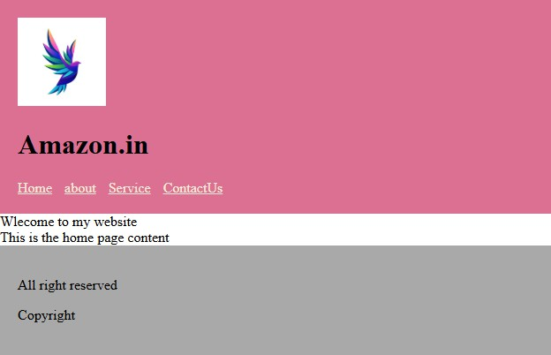

Module - 2

- Write a program to demonstrate the ViewState.
  - Aim:
  - Objective:
  - Theory :
  - Code :web.aspx
<%@ Page Language="C#" AutoEventWireup="true" CodeBehind="WebForm1.aspx.cs" Inherits="WebApplication5.WebForm1"
%>

<!DOCTYPE html>

<html xmlns="http://www.w3.org/1999/xhtml">
<head runat="server">
<title></title>
</head>
<body>
<form id="form1" runat="server">
<div>
Enter Value:<asp:TextBox ID="TextBox1" runat="server"></asp:TextBox>
<br />
<br />
<br />
<asp:Button ID="Button1" runat="server" OnClick="Button1_Click" Text="Store" /> &nbsp;&nbsp;&nbsp;&nbsp;&nbsp;&nbsp;&nbsp;&nbsp;&nbsp;&nbsp; &nbsp;&nbsp;&nbsp;&nbsp;&nbsp;&nbsp;
<asp:Button ID="Button2" runat="server" OnClick="Button2_Click" Text="Display" />
<br />
<br />
<asp:Label ID="Label1" runat="server"></asp:Label>
</div>
</form>
</body>
</html>

web.aspx.cs using System;
using System.Collections.Generic;

using System.Linq; using System.Web; using System.Web.UI;
using System.Web.UI.WebControls;

namespace WebApplication5
{
public partial class WebForm1 : System.Web.UI.Page
{
protected void Page_Load(object sender, EventArgs e)
{

}

protected void Button1_Click(object sender, EventArgs e)
{
ViewState["msg"] = TextBox1.Text;

}

protected void Button2_Click(object sender, EventArgs e)
{
Label1.Text = "You hav entered " + ViewState["msg"].ToString();
}
}
}

  - Output:
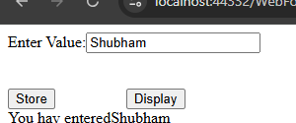

- Write a program to demonstrate the Hidden Object.
  - Aim:
  - Objective:
  - Theory :

  - Code :web1.aspx
<%@ Page Language="C#" AutoEventWireup="true" CodeBehind="WebForm2.aspx.cs" Inherits="WebApplication5.WebForm2"
%>

<!DOCTYPE html>

<html xmlns="http://www.w3.org/1999/xhtml">
<head runat="server">
<title></title>
</head>
<body>
<form id="form1" runat="server">
<div>

Value="Kunal" />
<br />
<br />
<asp:HiddenField ID="HiddenField1" runat="server"

<asp:Button ID="Button1" runat="server"

PostBackUrl="~/WebForm3.aspx" Text="Next" />
<br />
</div>
</form>
</body>
</html>

Create another webform 1st form button take postbackurl another form web2.aspx.cs
using System;
using System.Collections.Generic; using System.Linq;
using System.Web; using System.Web.UI;
using System.Web.UI.WebControls;

namespace WebApplication5
{
public partial class WebForm3 : System.Web.UI.Page
{
protected void Page_Load(object sender, EventArgs e)

{
Response.Write(Request.Form["HiddenField1"].ToString());
}
}
}

  - Output:
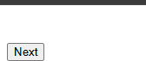


- Write a program to demonstrate the Query String
  - Aim:
  - Objective:
  - Theory :
  - Code :
  - web1.aspx
<%@ Page Language="C#" AutoEventWireup="true" CodeBehind="WebForm4.aspx.cs" Inherits="WebApplication5.WebForm4"
%>

<!DOCTYPE html>

<html xmlns="http://www.w3.org/1999/xhtml">
<head runat="server">
<title></title>
</head>
<body>
<form id="form1" runat="server">
<div>
Enter Value:<asp:TextBox ID="TextBox1" runat="server"></asp:TextBox>
<br />
<br />
<br />
<asp:Button ID="Button1" runat="server" OnClick="Button1_Click" Text="Send" />
</div>
</form>
</body>

</html>

Web1.aspx.cs using System;
using System.Collections.Generic; using System.Linq;
using System.Web; using System.Web.UI;
using System.Web.UI.WebControls;

namespace WebApplication5
{
public partial class WebForm4 : System.Web.UI.Page
{
protected void Page_Load(object sender, EventArgs e)
{

}

protected void Button1_Click(object sender, EventArgs e)
{
Response.Redirect("WebForm5.aspx?msg=" + TextBox1.Text);
}
}

}
Web2.aspx.cs using System;
using System.Collections.Generic; using System.Linq;
using System.Web; using System.Web.UI;
using System.Web.UI.WebControls;

namespace WebApplication5
{
public partial class WebForm5 : System.Web.UI.Page
{
protected void Page_Load(object sender, EventArgs e)
{

if (Request.QueryString["msg"] != null)
{
Response.Write(Request.QueryString["msg"].ToString());
}
else {
Response.Redirect("WebForm4.aspx");
}
}
}
}
  - Output:
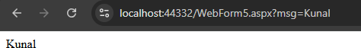

- Create a web application to get following information from a user. Name, Age, height, Email, Gender. Validate the input by using proper validation control. If the gender is male then navigate to Male.aspx web page, and if the gender is female then navigate to Female.aspx. Then depending upon the gender and height of the individual suggest the ideal weight.
[Note : use cookies to pass information between pages] The height to weight ratio is as follows
Height (CM) | 150 | 160 | 170 | 180 | 190
Ideal weight for Male | 60 | 65 | 70 | 75 | 80
Ideal weight for Female | 55 | 60 | 65 | 70 | 75

  - Aim:
  - Objective:
  - Theory :
  - Code :
  - web1.aspx
<%@ Page Language="C#" AutoEventWireup="true" CodeBehind="WebForm6.aspx.cs" Inherits="WebApplication5.WebForm6"
%>

<!DOCTYPE html>

<html xmlns="http://www.w3.org/1999/xhtml">
<head runat="server">
<title></title>
</head>
<body>
<form id="form1" runat="server">
<asp:Label ID="Label1" runat="server" Text="Name"></asp:Label>
:<asp:TextBox ID="TextBox1" runat="server"></asp:TextBox>
<br />
<br />
<asp:Label ID="Label2" runat="server" Text="Age"></asp:Label>
:<asp:TextBox ID="TextBox2" runat="server"></asp:TextBox>
<br />
<br />
<asp:Label ID="Label3" runat="server" Text="Height"></asp:Label>
:<asp:TextBox ID="TextBox3" runat="server"></asp:TextBox>
<br />
<br />
<asp:Label ID="Label4" runat="server" Text="Email"></asp:Label>
:<asp:TextBox ID="TextBox4" runat="server"></asp:TextBox>
<br />
<br />
Gender:<asp:RadioButton ID="RadioButton1" runat="server" Text="Male" />
&nbsp;<asp:RadioButton ID="RadioButton2" runat="server" Text="Female" />
<br />
<br />
<asp:Button ID="Button1" runat="server" OnClick="Button1_Click" Text="Submit" />
</form>
</body>
</html>

web1.aspx.cs using System;
using System.Collections.Generic;

using System.Linq; using System.Web; using System.Web.UI;
using System.Web.UI.WebControls;

namespace WebApplication5
{
public partial class WebForm6 : System.Web.UI.Page
{
protected void Page_Load(object sender, EventArgs e)
{

}

protected void Button1_Click(object sender, EventArgs e)
{
HttpCookie cookie = new HttpCookie("data"); cookie.Values["Name"] = TextBox1.Text; cookie.Values["age"] = TextBox2.Text; cookie.Values["height"] = TextBox3.Text; cookie.Values["email"] = TextBox4.Text; string gender = "";
if (RadioButton1.Checked) { gender = "Male"; }
if (RadioButton1.Checked) { gender = "Female"; } cookie.Values["gender"] = gender; Response.Cookies.Add(cookie);
if (gender == "Male")
{
Response.Redirect("~/Male7.aspx");
}
else
{
Response.Redirect("~/Female7.aspx");
}
}
}
}
Male.aspx.cs using System;
using System.Collections.Generic;

using System.Linq; using System.Web; using System.Web.UI;
using System.Web.UI.WebControls;

namespace WebApplication5
{
public partial class Male7 : System.Web.UI.Page
{
protected void Page_Load(object sender, EventArgs e)
{
int weight = 0;
string name = Request.Cookies["data"].Values["name"]; string age = Request.Cookies["data"].Values["age"]; string height = Request.Cookies["data"].Values["height"]; string email = Request.Cookies["data"].Values["email"]; if (int.Parse(height) == 150) { weight = 60; }
if (int.Parse(height) == 160) { weight = 66; } if (int.Parse(height) == 170) { weight = 70; } if (int.Parse(height) == 180) { weight = 75; } if (int.Parse(height) == 190) { weight = 80; }
Response.Write("Name:" + name + "\n age:" + age + "\n height: " + height + "\n email:" + email + "\n Ideal Weight:" + weight);
}
}
}
Female.aspx.cs using System;
using System.Collections.Generic; using System.Linq;
using System.Web; using System.Web.UI;
using System.Web.UI.WebControls;

namespace WebApplication5
{
public partial class Female7 : System.Web.UI.Page
{
protected void Page_Load(object sender, EventArgs e)
{

int weight = 0;
string name = Request.Cookies["data"].Values["name"]; string age = Request.Cookies["data"].Values["age"]; string height = Request.Cookies["data"].Values["height"]; string email = Request.Cookies["data"].Values["email"]; if (int.Parse(height) == 150) { weight =55; }
if (int.Parse(height) == 160) { weight = 60; } if (int.Parse(height) == 170) { weight = 65; } if (int.Parse(height) == 180) { weight = 70; } if (int.Parse(height) == 190) { weight = 75; }
Response.Write("Name:" + name + "\n age:" + age + "\n height: " + height + "\n email:" + email + "\n Ideal Weight:" + weight);
}
}
}

- Output:
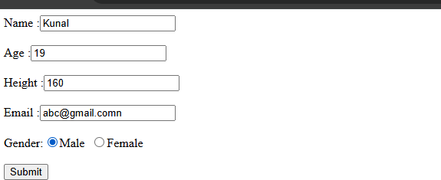

- Write a program to demonstrate session state.
  - Objective :

  - Theory :
  - Code : Webform1.aspx
<%@ Page Language="C#" AutoEventWireup="true" CodeBehind="WebForm1.aspx.cs" Inherits="WebApplication6.WebForm1"
%>

<!DOCTYPE html>

<html xmlns="http://www.w3.org/1999/xhtml">
<head runat="server">
<title></title>
</head>
<body>
<form id="form1" runat="server">
<asp:Label ID="Label1" runat="server" Text="First Name"></asp:Label>
<asp:TextBox ID="TextBox1" runat="server"></asp:TextBox>
<br />
<br />
<br />
<div>
<asp:Label ID="Label2" runat="server" Text="Last NAme"></asp:Label>
<asp:TextBox ID="TextBox2" runat="server"></asp:TextBox>
<br />
<br />
<asp:Button ID="Button1" runat="server" OnClick="Button1_Click" Text="Submit" />
</div>
</form>
</body>
</html>

webform1.aspx.cs using System;
using System.Collections.Generic; using System.Linq;
using System.Web; using System.Web.UI;

using System.Web.UI.WebControls;

namespace WebApplication6
{
public partial class WebForm1 : System.Web.UI.Page
{
protected void Page_Load(object sender, EventArgs e)
{

}

protected void Button1_Click(object sender, EventArgs e)
{
Session["Fname"] = TextBox1.Text; Session["Lname"] = TextBox2.Text; Response.Redirect("Session2.aspx");
}
}
}

Session1.aspx.cs using System;
using System.Collections.Generic; using System.Linq;
using System.Web; using System.Web.UI;
using System.Web.UI.WebControls;

namespace WebApplication6
{
public partial class Session : System.Web.UI.Page
{
protected void Page_Load(object sender, EventArgs e)
{
if (Session["Fname"] != null && Session["Lname"] != null)
{
string fname = Session["Fname"].ToString(); string lname = Session["Lname"].ToString();
Response.Write("First name=" + fname + "Last name= " + lname);

}
else {
Response.Redirect("WebForm1.aspx");

}
}
}
}

  - Output :
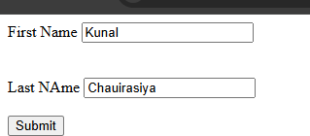
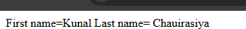

- Write a program to count the number of live users in your web application.
  - Aim:
  - objective:
  - Theory :
  - Code :
global.aspx.cs using System;
using System.Collections.Generic; using System.Linq;
using System.Web;
using System.Web.Security; using System.Web.SessionState;

namespace WebApplication6
{
public class Global : System.Web.HttpApplication
{

protected void Application_Start(object sender, EventArgs e)
{
Application["sessioncount"] = 0;

}

protected void Session_Start(object sender, EventArgs e)
{
Application.Lock();
int count = (int)Application["sessioncount"]; Application["sessioncount"] = count + 1; Application.UnLock();
}

protected void Application_BeginRequest(object sender, EventArgs e)
{

}

protected void Application_AuthenticateRequest(object sender, EventArgs e)
{

}

protected void Application_Error(object sender, EventArgs e)
{

}

protected void Session_End(object sender, EventArgs e)
{
Application.Lock();
int count = (int)Application["sessioncount"]; Application["sessioncount"] = count -1; Application.UnLock();
}

protected void Application_End(object sender, EventArgs e)
{

}
}
}
Web.config
<sessionState mode="InProc" cookieless="UseUri" timeout="1"></sessionState>
Take a normal webform.aspx and one control label webform.aspx.cs
using System;
using System.Collections.Generic; using System.Linq;
using System.Web; using System.Web.UI;
using System.Web.UI.WebControls;

namespace WebApplication6
{
public partial class WebForm2 : System.Web.UI.Page
{
protected void Page_Load(object sender, EventArgs e)
{
Label1.Text="Total visitor =" + Application["sessioncount"].ToString();
}
}
}

  - Output :
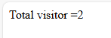

- Write a web application to display digital clock using ajax.
  - Aim :
  - Objective :
  - Theory :
  - Code :
  - webform1.aspx

<%@ Page Language="C#" AutoEventWireup="true" CodeBehind="WebForm1.aspx.cs" Inherits="WebApplication7.WebForm1"
%>

<!DOCTYPE html>

<html xmlns="http://www.w3.org/1999/xhtml">
<head runat="server">
<title></title>
</head>
<body>
<form id="form1" runat="server">
<div>
<asp:ScriptManager ID="ScriptManager1" runat="server">
</asp:ScriptManager>
<br />
<asp:UpdatePanel ID="UpdatePanel1" runat="server">
<ContentTemplate>

<asp:Timer ID="Timer3" runat="server" Interval="10000" OnTick="Timer3_Tick">
</asp:Timer>
<br />
<asp:Label ID="Label1" runat="server" Text="Label" BackColor="#FF66FF" CssClass="red"></asp:Label>

</ContentTemplate>
<Triggers>
<asp:AsyncPostBackTrigger ControlID="Timer3"
EventName="tick" />
</Triggers>
</asp:UpdatePanel>
</div>
</form>
</body>
</html>
webform1.aspx.cs
protected void Timer3_Tick(object sender, EventArgs e)
{
Label1.Text = DateTime.Now.ToString();

}

  - Output :

- Write a web application to create an image slider using ajax.
  - Aim :
  - Objective :
  - Theory :
  - Code : Webform1.aspx
<%@ Page Language="C#" AutoEventWireup="true" CodeBehind="WebForm1.aspx.cs" Inherits="WebApplication1.WebForm1"
%>

<!DOCTYPE html>

<html xmlns="http://www.w3.org/1999/xhtml">
<head runat="server">
<title></title>
</head>
<body>
<form id="form1" runat="server">
<div>
<asp:ScriptManager ID="ScriptManager1" runat="server">
</asp:ScriptManager>
<asp:UpdatePanel ID="UpdatePanel1" runat="server">
<ContentTemplate>
<asp:Image ID="image1" runat="server" Height="300" />
<asp:Timer ID="Timer1" runat="server" Interval="3000" OnTick="Timer1_tick" />
</ContentTemplate>
<Triggers>
<asp:AsyncPostBackTrigger ControlID="Timer1"
EventName="tick"/>
</Triggers>

</asp:UpdatePanel>
<br />
</div>
</form>
</body>
</html>

webform1.aspx.cs using System;
using System.Collections.Generic; using System.Linq;
using System.Web; using System.Web.UI;
using System.Web.UI.WebControls;

namespace WebApplication1
{
public partial class WebForm1 : System.Web.UI.Page
{
static int i = 0;
protected void Page_Load(object sender, EventArgs e)
{

}

protected void Timer1_tick(object sender, EventArgs e)
{
if (i == 0)
{
image1.ImageUrl = "~/Image/Dogs.jpg"; i = 1;
}
else if (i == 1)
{
image1.ImageUrl = "~/Image/CAt.jpg"; i = 2;
}
else if (i == 2)
{

image1.ImageUrl = "~/Image/flower.jpg"; i = 3;
}
else
{
image1.ImageUrl = "~/Image/Nature.jpg"; i = 0;
}

}
}
}

  - Output:

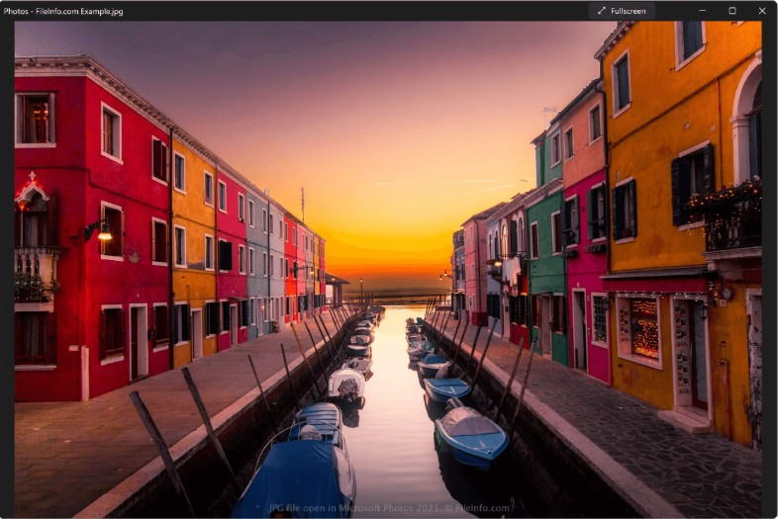

- Write a program to select state and on the basis of state fill city information using ajax.
  - Aim :
  - Objective :
  - Theory :
  - Code : Webform.aspx
<%@ Page Language="C#" AutoEventWireup="true" CodeBehind="WebForm2.aspx.cs" Inherits="WebApplication1.WebForm2"
%>

<!DOCTYPE html>

<html xmlns="http://www.w3.org/1999/xhtml">
<head runat="server">
<title></title>
</head>

<body>
<form id="form1" runat="server">
<div>
<asp:ScriptManager ID="ScriptManager1" runat="server">
</asp:ScriptManager>
<br />
<asp:UpdatePanel ID="UpdatePanel1" runat="server">
<ContentTemplate> Select State:
<asp:DropDownList ID="DropDownList1" runat="server" AutoPostBack="True" OnSelectedIndexChanged="DropDownList1_SelectedIndexChanged">
<asp:ListItem>Gujrat</asp:ListItem>
<asp:ListItem>Goa</asp:ListItem>
<asp:ListItem>Maharashtra</asp:ListItem>
</asp:DropDownList>
<br />
<br />
Select city:&nbsp;
<asp:DropDownList ID="DropDownList2" runat="server">
<asp:ListItem>City</asp:ListItem>
</asp:DropDownList>
</ContentTemplate>
<Triggers>
<asp:AsyncPostBackTrigger ControlID="DropDownList1" EventName="SelectedIndexChanged" />
</Triggers>
</asp:UpdatePanel>
</div>
</form>
</body>
</html>

webform.aspx.cs using System;
using System.Collections.Generic; using System.Linq;
using System.Web; using System.Web.UI;
using System.Web.UI.WebControls;

namespace WebApplication1
{
public partial class WebForm2 : System.Web.UI.Page
{
protected void Page_Load(object sender, EventArgs e)
{

}

protected void DropDownList1_SelectedIndexChanged(object sender, EventArgs e)
{
DropDownList2.Items.Clear(); if(DropDownList1.SelectedItem.Text== "Maharashtra")
{
DropDownList2.Items.Add("Mumbai"); DropDownList2.Items.Add("Pune"); DropDownList2.Items.Add("NAGPUR"); DropDownList2.Items.Add("aURANGABAD");
}
if (DropDownList1.SelectedItem.Text == "Goa")
{
DropDownList2.Items.Add("Panaji"); DropDownList2.Items.Add("Margo"); DropDownList2.Items.Add("Vasco da gama");

}
if (DropDownList1.SelectedItem.Text == "Gujrat")
{
DropDownList2.Items.Add("Gandhinagr"); DropDownList2.Items.Add("Surat"); DropDownList2.Items.Add("Ahemdabad");

}
}
}
}

- Output :
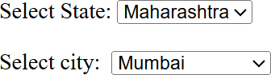

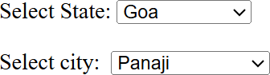

- Write a web application to demonstrate page output caching.
  - Aim :
  - Objective :
  - Theory :
  - Code : Webform1.aspx
<%@ Page Language="C#" AutoEventWireup="true" CodeBehind="WebForm1.aspx.cs" Inherits="WebApplication1.WebForm1"
%>
<%@ OutputCache Duration="10" VaryByParam="None" %>
<!DOCTYPE html>

<html xmlns="http://www.w3.org/1999/xhtml">
<head runat="server">
<title></title>
</head>
<body>
<form id="form1" runat="server">
<div>
<h1>Output Caching</h1> At the tone, the toime will be:
<%=DateTime.Now.ToString() %>

</div>
</form>
</body>
</html>

  - Output :
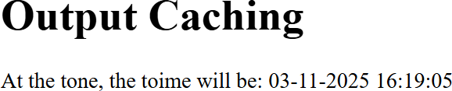

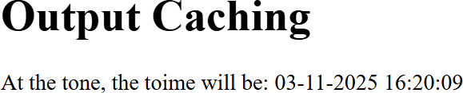

- Write a web application to demonstrate data caching.
  - Aim :
  - Objective :
  - Theory :
  - Code :
  - webform.aspx
<%@ Page Language="C#" AutoEventWireup="true" CodeBehind="WebForm3.aspx.cs" Inherits="WebApplication1.WebForm3"
%>

<!DOCTYPE html>

<html xmlns="http://www.w3.org/1999/xhtml">
<head runat="server">
<title></title>
</head>
<body>
<form id="form1" runat="server">
<p style="height: 80px">

Data Caching</p>
<asp:Button ID="Button1" runat="server"
OnClick="Button1_Click1" Text="GetData" />

<asp:Label ID="Label1" runat="server"></asp:Label>

</form>
</body>
</html>
webform.aspx.cs using System;
using System.Collections.Generic; using System.Linq;
using System.Web; using System.Web.UI;
using System.Web.UI.WebControls;

namespace WebApplication1
{
public partial class WebForm3 : System.Web.UI.Page
{
protected void Page_Load(object sender, EventArgs e)
{

}

protected void Button1_Click(object sender, EventArgs e)
{
String cachedData = (string)Cache["CachedData"]; if(cachedData == null)
{
cachedData = GetDataFromDatabase();
Cache.Insert("CachedData", cachedData, null, DateTime.Now.AddSeconds(10),TimeSpan.Zero);
}
Label1.Text = cachedData;
}
private string GetDataFromDatabase()
{
return "Data retrieved at:" + DateTime.Now.ToString("hh:mm:ss");

}
}
}
  - Output :
